**PANDAS:**

1. **IMPORTING PANDAS & READING DATASET:**

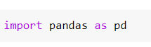





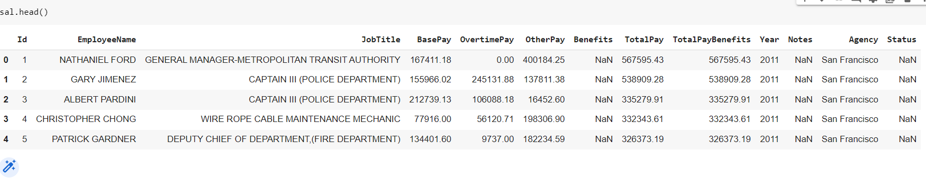

1. **Use the .info() method to find out how many entries there are**

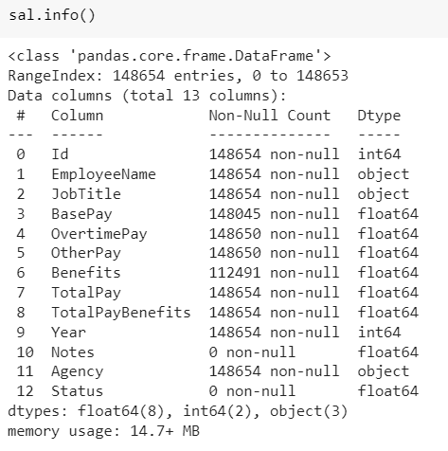

1. **What is the average BasePay ?**

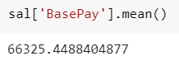

1. **What is the highest amount of OvertimePay in the dataset ?**

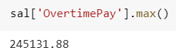

1. **What is the job title of JOSEPH DRISCOLL ? Note: Use all caps, otherwise you may get an answer that doesn't match up (there is also a lowercase Joseph Driscoll).**

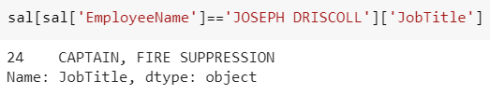

1. **How much does JOSEPH DRISCOLL make (including benefits)?**

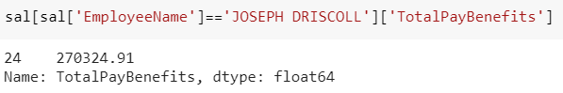

1. **What is the name of highest paid person (including benefits)?**

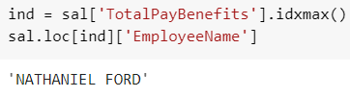

1. **What is the name of lowest paid person (including benefits)? Do you notice something strange about how much he or she is paid?**

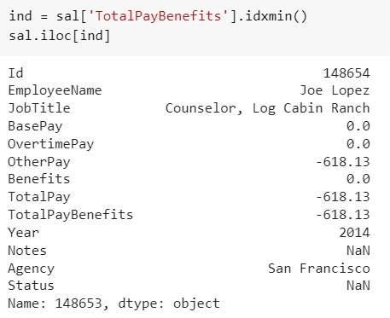

1. **What was the average (mean) BasePay of all employees per year? (2011-2014) ?**

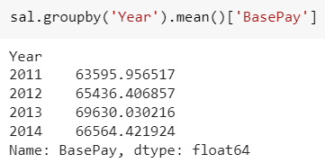

1. **How many unique job titles are there?**

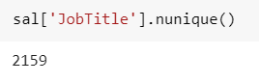

1. **What are the top 5 most common jobs?**

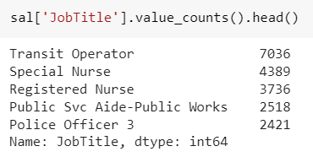

1. **How many Job Titles were represented by only one person in 2013? (e.g. Job Titles with only one occurence in 2013?)**

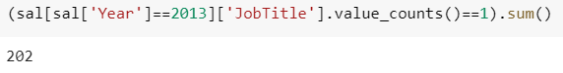

1. **How many people have the word Chief in their job title?**

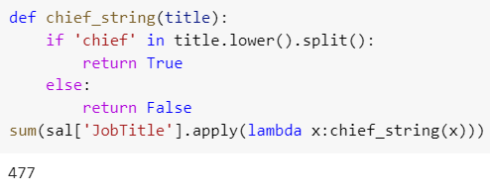

1. **Is there a correlation between length of the Job Title string and Salary?**

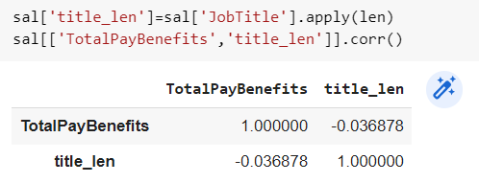

**CONCLUSION:**

#### From this practical, I have successfully learned about pandas library in python.